**Ideation Phase**

**Define the Problem Statements**

|  |  |
| --- | --- |
| Date | 19 September 2022 |
| Team ID | PNT2022TMID18036 |
| Project Name | Project - Smart Fashion Recommender Application |
| Maximum Marks | 2 Marks |

**Customer Problem Statement**

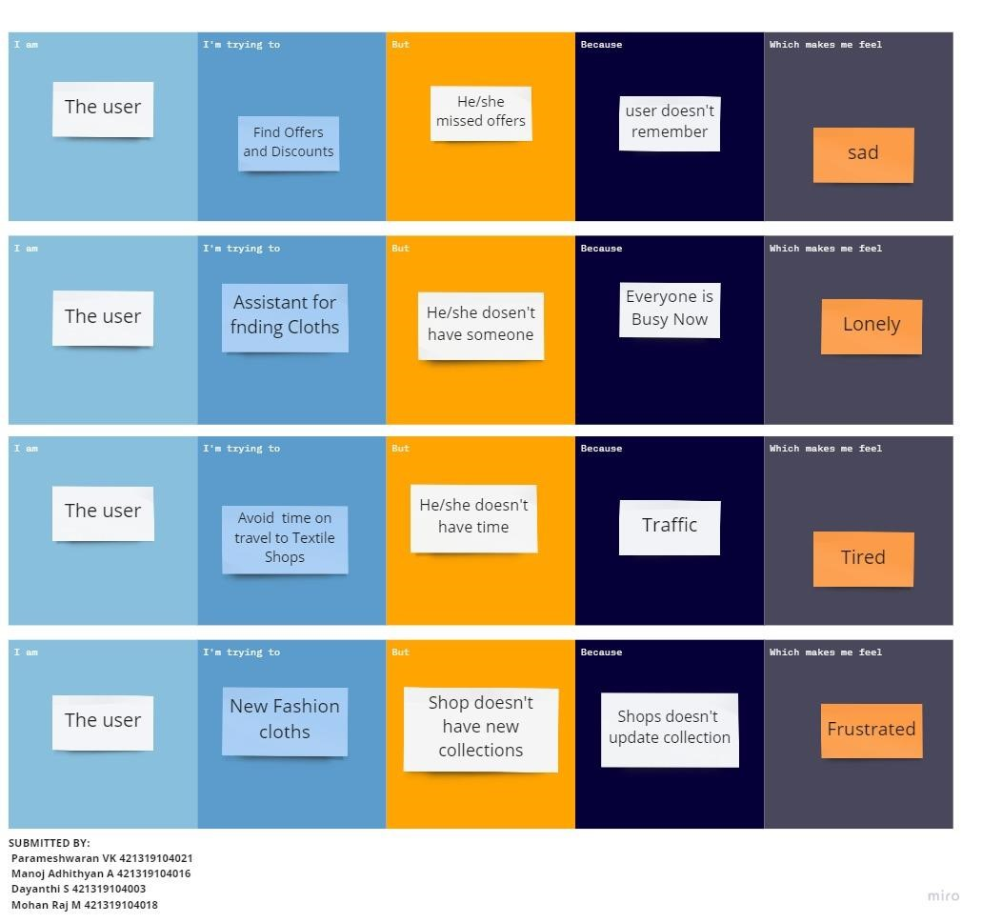

Submitted By:

RAMYADEVI RS 713319CS116

SAMYUKTHA V 713319CS124

SRIJA J 713319CS142

SUBIKSHA R 713319CS147